**Introduction:** The initial stages of breast cancer are characterized by an increase in vascularity of regions where a tumor is present. This results in the affected region being warmer and, when exposed to ambient conditions, cooling more slowly than the surrounding tissue [1]. Those characteristics allow thermographic analysis of a patient’s breasts to potentially be used to help diagnose early stages of breast cancer. Breast thermography has the benefits of being fast and requiring no contact nor any exposure to radiation, yet it is not an accepted form of diagnosing breast cancer. This project aims to develop a reliable method of distinguishing potentially tumorous regions from normal breast tissue based on objective thermographic analysis.

**Methods and Materials**: In this study, front-view thermal images of 16 patients known to have tumors on only one breast were obtained using an N2 Infrared Camera, with thermal resolution of 50 mK / digital count, for 15 minutes per patient. These images were then registered to account for deformation and patient movement and cropped to keep only the breast tissue in the final images. Due to the positions of the tumors on the patients, only 4 of the 16 patients were used in this preliminary study. For those patients, the average pixel value in the area known to have a tumor was recorded at each minute. The same measurements were also obtained from the corresponding region on the opposite breast as well as non-tumorous areas surrounding the nipples at clock hours 12, 3, 6, and 9 on both breasts. This allowed for the change in a region to be calculated at each minute in addition to the total change over the 15 minutes.

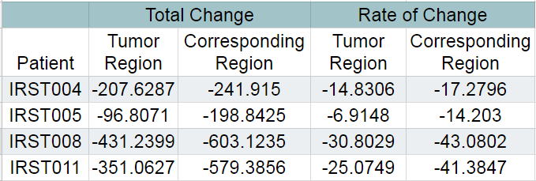The clustering algorithm DBSCAN (Density Based Spatial Clustering of Applications with Noise) was then implemented to identify and cluster pixels that were near each other in space and temperature [2]. To eliminate clusters containing only normal breast tissue, we implemented checks that evaluated spatial, physical, and temporal characteristics of the clusters. Clusters along the naturally warmer bottom border of the breast, extremely large and small clusters, and long, narrow clusters that were likely blood vessels were all removed. Additionally, the average temperature of the clusters at each minute was tracked over the 15-minute period. Clusters in the top 50th percentile with respect to both the total change and average rate of change were eliminated. Finally, clusters that changed more than the corresponding area on the opposite breast were removed. The remaining clusters then were compared to the truth region to assess the ability of the algorithm to find a tumorous region.

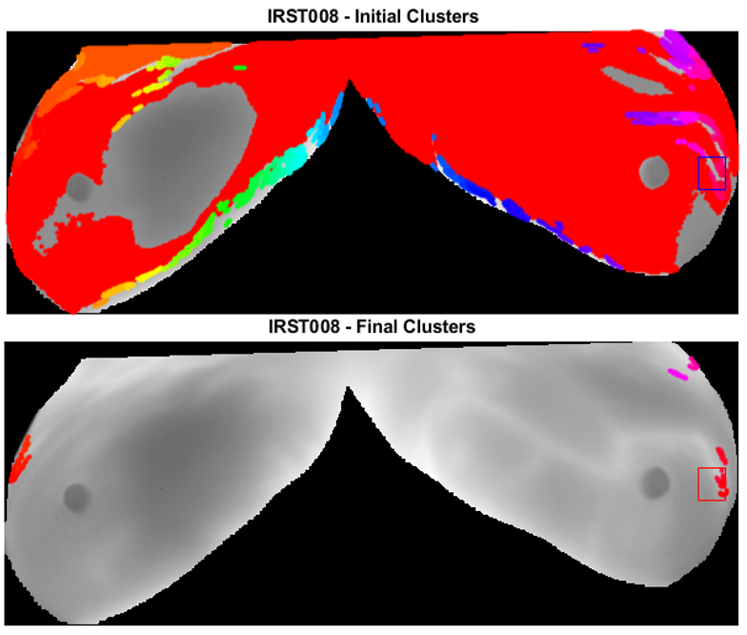**Results and Discussion:** The comparison of the thermal characteristics of the truth region and corresponding region on the healthy breast verified that the tumorous region changed less over the 15 minutes and had a lower rate of change. While all of the truth regions exhibited those characteristics, some of the normal regions exhibited this behavior as well, making it clear that additional checks were needed to eliminate clusters. The checks described above helped reduce the number of clusters by 90-95%, yielding clusters in and around the truth region for all four patients, with a few additional clusters. Ideally the cluster removal methods would be able to eliminate all clusters except for those in the area of the truth region; however, there were several factors preventing this. Inherent non-uniformity in the breast tissue and blood vessels created warm regions that were difficult to distinguish from tumor regions. Additionally, the lack of symmetry made it difficult in some cases to accurately compare one region of the breast to its corresponding region.

Figure: Table showing the data gathered from truth regions and corresponding regions of patients. Thermal images showing the initial clustering and the clusters remaining after analysis with the truth region identified.

**Conclusion**: The comparison of the thermal characteristics of the truth region to the same region on the opposite breast supported the evidence that tumorous regions are warmer and change less over time. This information, as well as the use of spatial and temporal information in the removal of clusters shows the promise of thermographic analysis as a means of breast cancer diagnosis. As more data are acquired and the methods of cluster removal are refined, the reliability of breast thermography will increase and contribute towards its acceptance in the medical field.

**References**: [1] Li Jiang, Phys. Med. Biol. 56 (2011) 187–202 [2] Heris, S (2015) DBSCAN Clustering Algorithm (Version 1.0) [Source Code]. http://yarpiz.com/255/ypml110-dbscan-clustering